SIMATS ENGINEERING
ASSESSMENT TOOL 3
COURSE NAME: Cryptography and Network Security
COURSE CODE: CSA51
COURSE OUTCOME COVERED
CO1: Apply classical encryption techniques using symmetric and asymmetric ciphers to encrypt and decrypt data for the ensuring data security. (BL3, BL4)
Assessment Tool Weightage: 10%
QUESTIONS: 5 Total Marks:50
Annexure A
TECHNICAL PRESENTATION
Code of Conduct:
I B.Varshini (192521182) (Name / Reg No) certify that this submission is my original work and that I have adhered to the guidelines specified for this assessment. I understand that any violation of academic integrity rules will result in disciplinary action.
Signature of the student:
Annexure A
TECHNICAL PRESENTATION
1. From Caesar to Vigenère: Evolution of Substitution Ciphers”
2. “Substitution vs Transposition: Which Provides Better Security?” 3. “Security Attacks, Threats, Risks and Their Impact on Security Goals” 4. “Steganography vs Cryptography: Hidden Security in the Digital World” 5. “Role of Number Theory in Cryptography: From Euclid to Euler”
RUBRICS FOR CALCULATION:
Criteria | Weighta ge | Level 4 –  Exemplary | Level 3 –  Proficient | Level 2 –  Developing | Level 1 –  Beginning
Understandi ng of  Concepts | 25 | Demonstrates  thorough  understanding  and effectively  integrates multiple concepts/technolo gies | Good  understandi ng with  proper  integration  of most  concepts | Basic  understandin g; limited or partial  integration | Poor  understandin g; unable to integrate  concepts
Experiment al Design | 30 | Well-planned,  systematic  implementation with optimal  solution | Correct  implementat ion with  minor issues | Basic  implementati on with errors or  inefficiencies | Incorrect or  incomplete  implementati on
Use of  Tools | 20 | Effective and  advanced use of tools/technologies with proper  configuration | Appropriate use of tools with correct execution | Limited or  inconsistent use of tools | Incorrect or  minimal use of tools
Analysis of Results | 15 | Insightful analysis with accurate  interpretation and validation of  results | Good  analysis  with  reasonable interpretatio n | Basic  analysis with limited  insights | Poor or  incorrect  analysis of  results
Documentat ion | 10 | Clear, well  structured  documentation  with diagrams,  code, and results | Organized  documentati on with  necessary  details | Basic  documentatio n with  missing  details | Poor or  incomplete  documentatio n

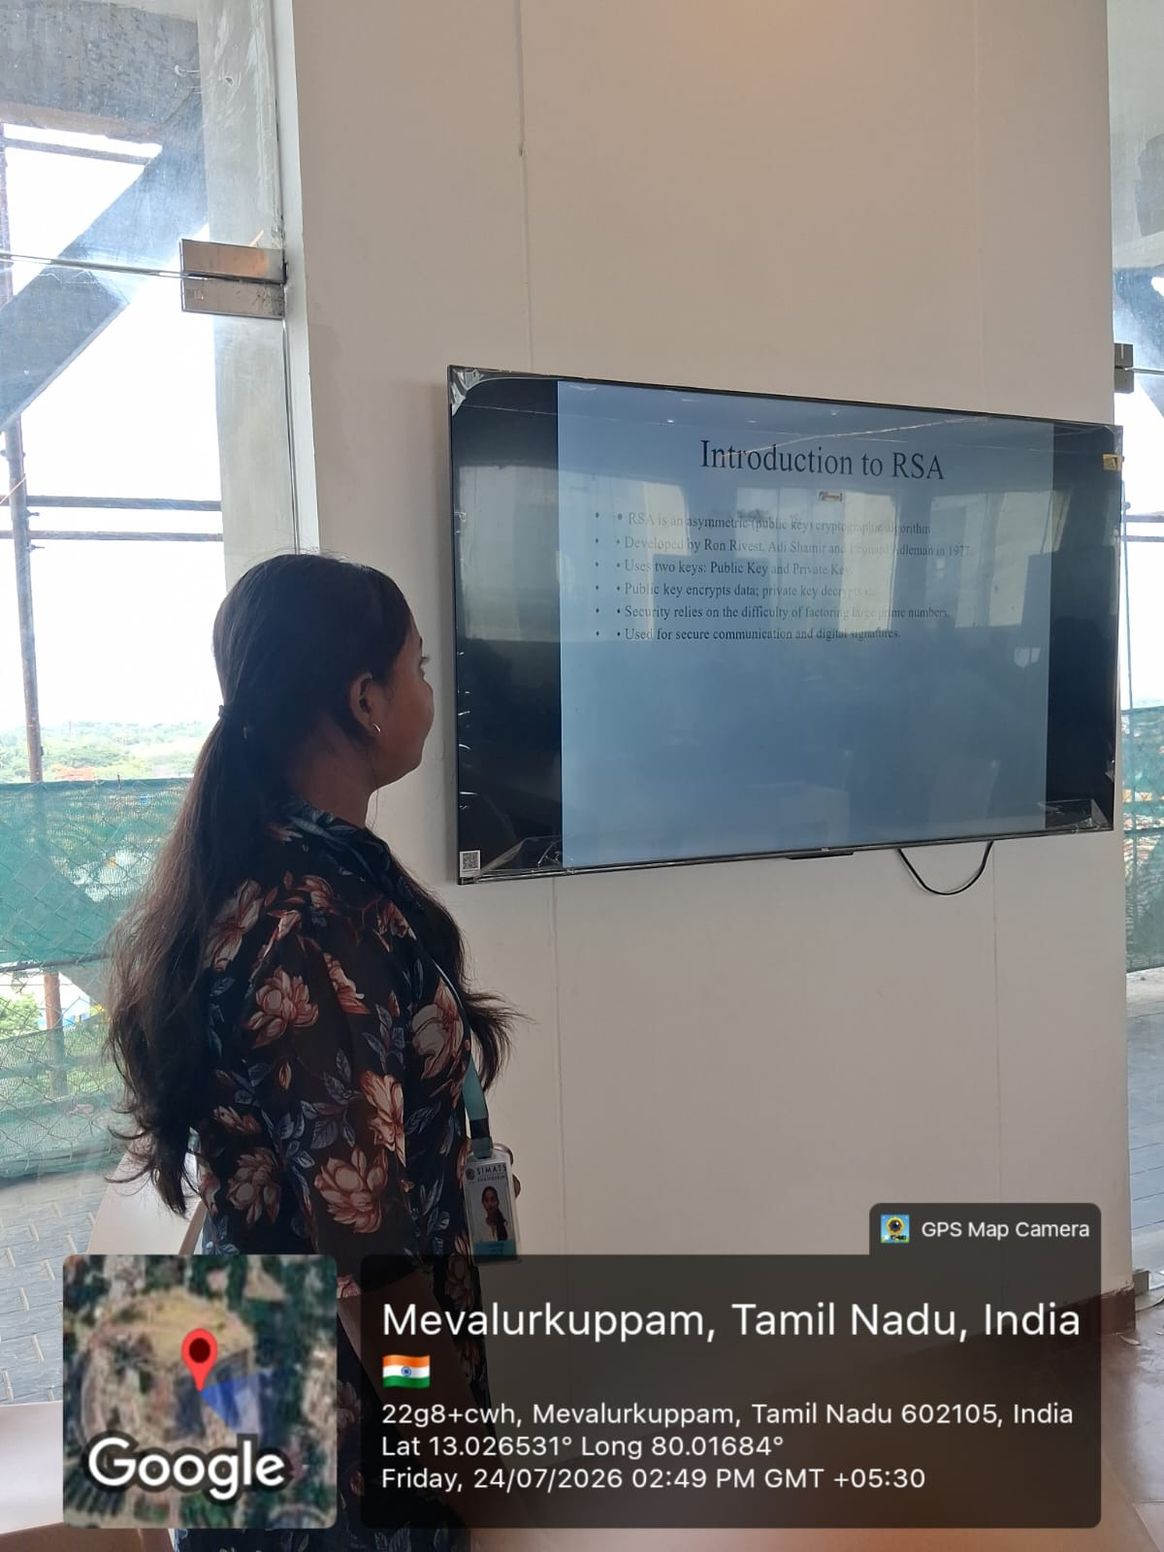

Title: RSA Algorithm in Cryptography
Description:
The RSA (Rivest–Shamir–Adleman) algorithm is one of the most widely used public-key cryptographic algorithms for securing digital communication. It was developed in 1977 by Ron Rivest, Adi Shamir, and Leonard Adleman. RSA uses a pair of mathematically related keys: a public key for encryption and a private key for decryption. This ensures that only the intended recipient can access the original message.
The security of RSA is based on the computational difficulty of factoring the product of two large prime numbers. It provides confidentiality, authentication, integrity, and non-repudiation through encryption and digital signatures. RSA is commonly used in secure communication protocols such as HTTPS, email encryption, VPNs, and digital certificates.
The RSA algorithm consists of three main phases:
- Key Generation – Generates a public key and a private key.
- Encryption – Encrypts plaintext using the recipient's public key.
- Decryption – Decrypts ciphertext using the recipient's private key.
Because of its strong security and reliability, RSA remains a fundamental algorithm in modern cryptography and is widely implemented in banking systems, e-commerce, secure websites, and digital identity systems.

